**Virtual Machine: Uses, Working, Examples**

A virtual machine also known as a Virtual Box is defined as a computer resource that functions like a physical computer and makes use of software resources only instead of using any physical computer for functioning, running programs, and deploying the apps. While using Virtual Machine the experience of end-user is the same as that of when using a physical device. Every virtual machine has its own operating system and it functions differently as compared to other Virtual Machine even if they all run on the same host system. A virtual machine has its own CPU, storage, and memory and can connect to the internet whenever it is required. A virtual machine can be implemented through firmware, hardware, and software or can be a combination of all of them. Virtual machine is used in cloud environments as well as in on-premise environments.

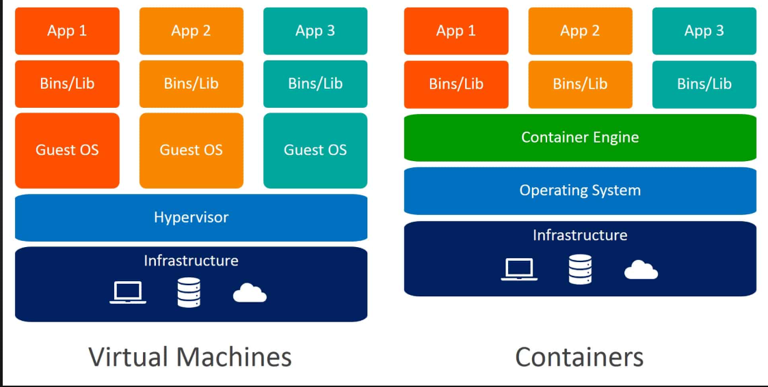

**Types of Virtual Machine**

There are two different types of virtual machines. They are:

* Process Virtual Machine
* System Virtual Machine

**1. Process Virtual Machine:** A process virtual machine is defined as a type of virtual machine that allows only a single process to run as an application on the host system and provides a platform-independent environment. A process VM gets created once the process is started and gets destroyed when the process ends. Java Virtual Machine (JVM) is an example of a process virtual machine that allows any operating system to run java applications.

**2. System Virtual Machine:**A system virtual machine is defined as a type of virtual machine that is fully virtualized to substitute a physical machine. The physical resources of the host device are shared among the multiple virtual machines. This process of virtualization depends upon a hypervisor that runs on the top of the operating system.

**Uses of Virtual Machine**

Below are the uses of virtual machines:

**1. Device Backup:** Virtual machines provide file backups as they copy the existing programs and operating systems. The applications and settings that are being used on other devices can be backed up with the help of virtual machines. In case of any issue with the device, it helps to access the prior versions of the operating system or the applications.

**2. Testing:**Virtual machines are being used for the purpose of testing for many use cases such as the beta release of software can be copied for testing before releasing the final overall versions of the products to the customers. The test scripts can also be tested through the software and make sure that everything that is developed works accordingly.

**3. Program Development:**Virtual machines help to individually develop the programs. The developers can code the applications in a new environment with the help of virtual machines. The versions can be directly deployed to the cloud for other available users if the virtual machine has connections to the cloud server.

**4. Cyber security:**The host devices can be used to run the programs if the live devices have any security-related issues. It helps to protect the data and devices of the employees in the organizations. Virtual machines are being used by many cybersecurity professionals for inspecting existing cybersecurity-related issues.

**Working**

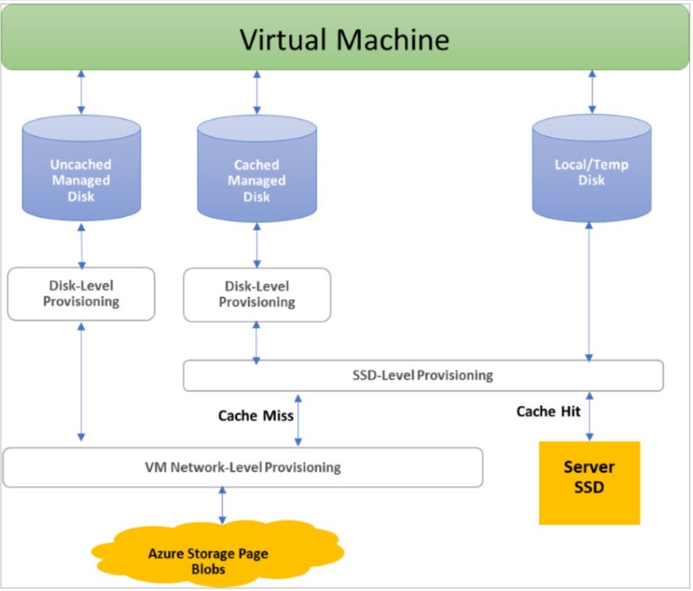

* Virtualization provides with dedicated software based memory, CPU and storage.
* The overall process is then done by the hypervisor software.
* According to the need the resources are being moved from the host towards the guest by the hypervisor. Hypervisor also schedules the operations in virtual machines in order to avoid the conflicts that can arise while using the resources.
* As virtual machine is separated from the remaining system, it has no access to make any unapproved modifications to the host computer systems.
* This is done for preventing the virtual machines from interfering with the central operating systems of the host.

**Examples**

Below are the examples of most widely used virtual machine software:

**1. Parallels Desktops:** In order to run on Mac devices parallel desktop software provides with the feature of hardware virtualization for the windows without performing the process of rebooting. The applications provided by them are fastest and are most powerful too. It provides with the real time delivery of data such as consumption statistics and licensing actions. Parallel desktops supports various platforms such as Windows 11,10,8.1 and 7, Linux and MacOS. It provides with the feature to switch easily from Mac to Windows and also has no complex keyboard shortcuts.

**2. Citrix Hypervisor:**Citrix hypervisor simplifies the overall operational administration that enables the users to perform complex and intense tasks in a virtualized environments. Citrix hypervisor is considered as one of the best VM for Windows 10 operating system. It provides with the secure environment for accessing and storing the large files. The apps can be accessed by the users from any device in the public cloud. Citrix hypervisor provides with the feature for enhanced graphic workloads.

**3. Red Hat Virtualization:** Red Hat Virtualization is a open-source platform that provides with a centralized management and enables its users for creating new virtual machines. It is also used to replicate the existing one for checking the overall functioning. Red hat virtualization supports various platforms such as Windows and Linux. It allows integration with the different systems and provides with very high performance for cloud environments and Kubernetes.

**4. VMware Workstation Player:** VMware Workstation Player provides with a support for various types of operating systems on a single machine. VMware workstation provides efficient sharing of data between hosts and the guest systems. The users can acquire a license for the business usage while using VMware workstation. It supports various platforms such as 64-bit Windows and Linux operating system, CentOS and Ubuntu.